

**Minutes of a virtual meeting of the**

**FINANCE, PLANNING & ADMINISTRATION COMMITTEE**

**OF RAINFORD PARISH COUNCIL**

**held via Zoom on Wednesday 11 November 2020 commencing at 6.30pm**

**Present: Councillors: Bardsley, Jones (Chairman), Long, Monk, Sterry**

**In Attendance: Sally Powell (Clerk)**

The Chairman welcomed Councillor Bardsley to the meeting

**1. Apologies:**

None

**2. Approval of the Minutes of the meeting of the Finance, Planning & Administration Committee held on 14.10.2020:**

The minutes of the meeting held on 14.10.2020 were agreed as a true and accurate record, proposed by Councillor Sterry, seconded by Councillor Monk and carried unanimously.

**3. Plans:**

*P/2020/0774/HHFP Demolition of existing single storey side extension with the erection of a single storey side and part rear extension 2 Helen Bank Drive*

*P/2020/0778/HHFP Two storey side and rear extension along with 2no dormer windows to side elevation 55 Cross Pit Lane*

There were no objections to the above sets of plans

**4. Clerk’s update report:**

1. Statements from the Government regarding COVID-19 continue to be monitored on a daily basis for relevance to the Parish Council and the Village Hall and the local COVID-19 case figures will be circulated as soon as they are available.
2. Due to further government COVID-19restrictions, all classes have been cancelled until 02.12.2020 at the earliest. Hall users have been informed.
3. The extension of the furlough scheme means that the caretakers and the Event Co-ordinator can be flexibly furloughed from 01.11.2020. The scheme will run until 31.03.2020. *The Chairman reminded the meeting that the Event Co-ordinator’s hours had been reduced from 30 to 25 per week from 01.10.2020. However, the extension of the CJRS means that the Event Co-ordinator could now also be furloughed. It was agreed that the role should be flexibly furloughed working a minimum of 5 hours per week and that the Parish Council would make up the 20% to keep the Event Co-ordinator on full salary.*

***RESOLVED: Councillor Jones proposed that the Event Co-ordinator is flexibly furloughed on the Government Coronavirus Job Retention Scheme from 01.11.2020, working a minimum of 5 hours per week. Additionally, the Caretakers will be re-furloughed from 01.11.2020. This was seconded by Councillor Long and carried unanimously***

1. The Clerk’s office has acted as the Booking Office for the Remembrance Day Zoom service. The Chairman has been filmed laying wreaths at the Church War memorial and the War memorial outside the Village Hall. Residents have been encouraged via social media to display poppies.
2. A payment was made to the PWLB on 02.11.2020.
3. The bar is currently closed for an undetermined length of time due to the COVID-19 restrictions which came into force on 05.11.2020.
4. At the time of preparing the agenda no further information regarding the refusal of the rate rebate was available. However ongoing discussions with officers from St Helens Council have been taking place. *The Clerk confirmed that there was no further update*
5. The cashflow document has been updated.
6. An application for a grant from the Liverpool City Region has been made. The criteria were changed once the England coronavirus lockdown was enforced from 05.11.2020. If successful, the Parish Council would receive £5000. *The Clerk confirmed that there was no further update*
7. The LALC AGM will take place on 14.11.2020. The following Councillors will be representing Rainford Parish Council: Bardsley, Brown, Monk, Sterry
8. There has been an on-going correspondence with the managing agents regarding the rubbish and fly-tipping behind the shops on Ormskirk Road. Some of the items have been removed, but the area has not yet been cleared as requested. *Councillor Monk thanked the Clerk for her assistance in getting this matter resolved*

**5. Income and Expenditure for October 2020:**

*See Appendix 1 for full details*

**Receipts for October 2020: £9654**

**Payments for October 2020: £13305**

**Amount invoiced in October 2020: £2220**

**Bank Balances as at 31.10.2020: Current A/C £5261 Business A/C £52120**

**Payments include staff costs for September 2020**

The Chairman highlighted the following:

October Receipts – From 02.11.2020, 2 of the offices have not been able to trade, so there may be requests for rent reductions in November

- £1000 had been received as a donation from the Rainford Senior Citizens Social Committee towards the cost of using the hall for Luncheon Club from April 2019 – January 2020

October Payments – The salaries included are for September 2020, not October 2020. Payroll seem to be working a month in arrears now.

- The invoices for bar stock were outstanding invoices from September 2020

Councillor Jones proposed that the figures were accepted as a true and accurate record. This was seconded by Councillor Long and carried unanimously.

**6. Revised Cashflow Document 2020/21:**

*See Appendix 2*

The Chairman informed the meeting of his intention to circulate the latest cashflow document to all Councillors reminding them of their collective responsibility for the financial position of the Parish Council. He also emphasised the following points:

* That the updated cashflow document assumed a worst-case scenario that there would not be any further income from the bar until the end of the financial year.
* There would be some minimal bar income in November 2020 as some of the bar stock has been sold off
* The refund from the caterer for a Chairman’s fund-raiser that was not able to take plac**e,** has not yet been received
* A contingency fund has been included in the Earmarked expenditure column
* It is hoped that it will be possible to hold some sort of beer festival in February 2021 and another revenue raising event in March 2021
* The income under staff costs is grants from the CJRS. The Clerk was asked to move the amount shown for November into December as it was not likely to be forthcoming during November 2020
* It is hoped that, with certain caveats, it will be possible to get to the end of the financial year and remain solvent

**7. Revised Budget for 2020/21 and Budget 2021/22:**

*See Appendix 3*

It was agreed that the budget should initially be prepared assuming that on 01.04.2021, the position will be the same as it is now, so it will be a worse-case scenario budget. It may be necessary to increase the precept to have enough funds to cover estimated expenses for the year. It is not possible to know or predict what will happen, but the budget can be revised throughout the year.

The budget will be based on a 75% occupancy rate for the offices.

Increasing the precept by £1.50 per band D equivalent would generate an additional £4500. This represents an increase of 6%

An increase of 8% would generate an additional £6000.

Depending on circumstances, it may be necessary to reconsider staffing levels.

Following a discussion, it was agreed that the Chairman would work on the budget with the Clerk and that a draft budget will be presented to the FPA committee meeting in December. This will be moved forward a week to 02.12.2020. Amendments can then be made before presentation of the budget at the full Council meeting that will be held on 14.12.2020, with a recommendation for what the precept should be set at.

**8. Income/Expenditure & Contingency plans:**

This item had been covered under other agenda headings

**9. Site for the Rainford Table Tennis Club clubhouse:**

The Clerk informed the meeting that RTTC did not wish to put their clubhouse on the site of the pavilion, but behind the tennis courts. They are also hoping that St Helens Council will create some parking spaces from some of the grassed area. The decision now lies with the planning department.

**10. The Surveyor’s Report:**

The requested priority list and summary had not yet been received. It was agreed that the repairs in the Clerk’s office should be prioritised and completed this financial year, if possible.

**11. Other Urgent Matters:**

1. Councillor Bardsley informed the meeting that the residential development behind the Red Cat had begun. The meeting was informed that there were now going to be 2 houses built and the access would be from Highfield Drive.
2. Councillor Jones informed the meeting that the old warehouses had been cleared from Lords Fold, so it was suspected that the residential development there of 52 houses might soon begin.
3. Councillor Monk informed the meeting that the Christmas Market could not be held on 22.11.2020. Stall holders had agreed to moving the date to 12.12.2020. It is hoped that the restrictions in place at that time, will allow for it to go ahead on this date.

There being no other business, the meeting closed at 7.15pm

**__________________________**

**Councillor Peter Jones**

**Chairman, Finance, Planning & Administration Committee 2020/21**

**Rainford Parish Council**

**Appendix 1**

**Item 5 – Income & Expenditure for October 2020**

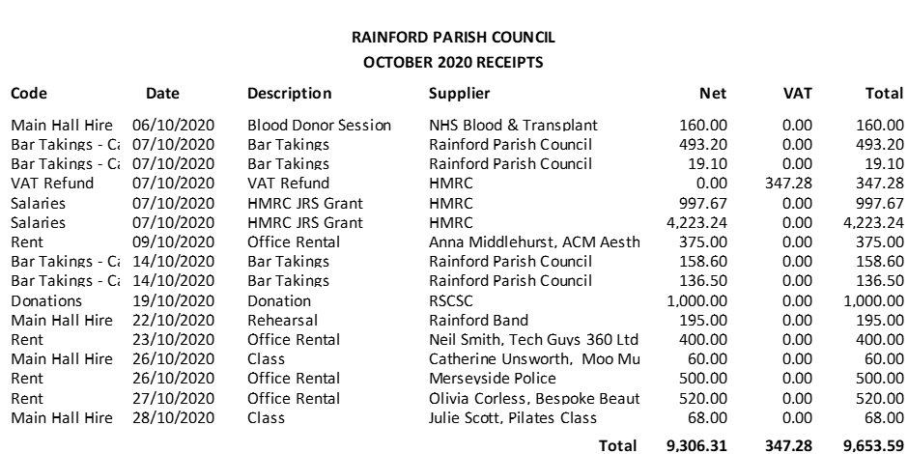

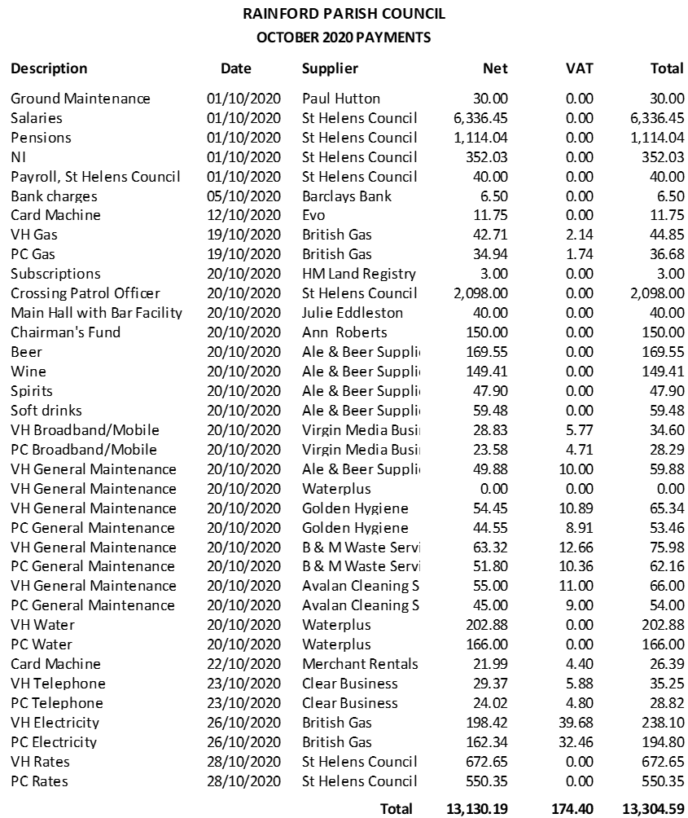

**Appendix 2**

**Item 6 Updated Cashflow**

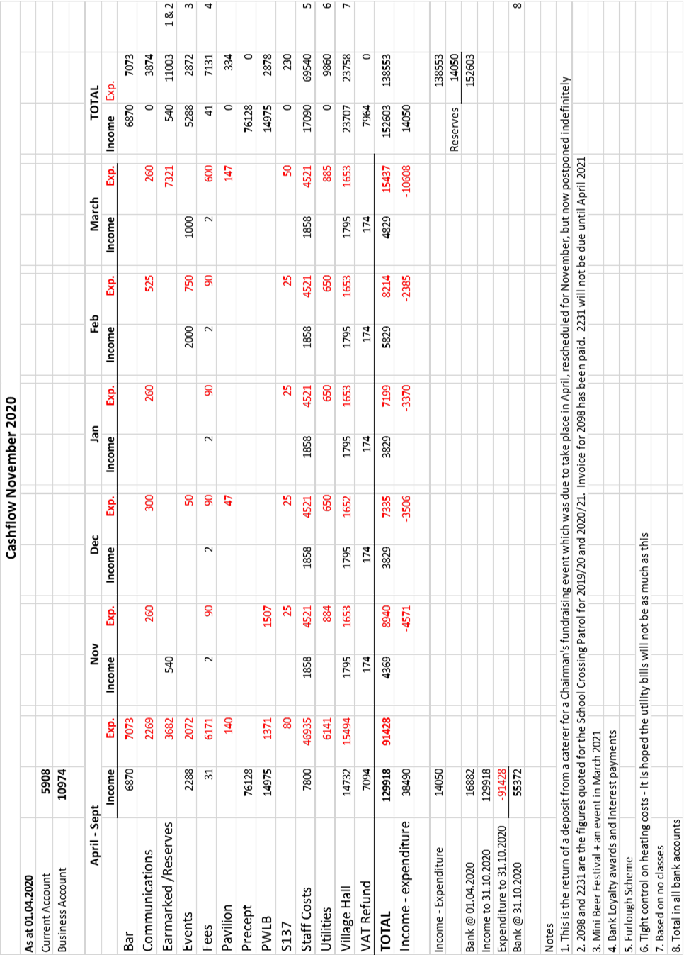

**Appendix 3**

**Item 7 Revised Budget 2020.21**

